**Air Quality Index in India**

**Introduction**

Air pollution means exactly what you think it means : it's when the quality of the air you breathe drops. But how does that happen ? That's the real question. It's induced by the presence of harmful, unwanted substances in air (more precisely, into Earth's atmosphere). Those bad substances are the pollutants and most of the tables in this database focus on those pollutants and give information about their preseance in the air. As said earlier, air pollution is due to the presence of some pollutants, it's time to learn more about the main pollutants that are present in our database :

* Sulphur dioxide (SO2) : This contaminant is mainly emitted during the combustion of fossil fuels such as crude oil and coal.
* Carbon monoxide (CO) : This gas consists during incomplete combustion of fuels example : A car engine running in a closed room.
* Nitrogen dioxide (NO2) : These contaminants are emitted by traffic, combustion installations and the industries.
* Ozone (O3) : Ozone is created through the influence of ultra violet sunlight (UV) on pollutants in the outside air.
* Particulate Matter (PM) : Particulate matter is the sum of all solid and liquid particles suspended in air. This complex mixture includes both organic and inorganic particles, such as dust, pollen, soot, smoke, and liquid droplets. These particles vary greatly in size, composition, and origin.

So how are those pollutants produced in our daily lives ? Well as you may have guessed, The main sources of air pollution are the industries, agriculture and traffic (held responsible for one-third of the greenhouse gas emissions). That being said, us consumers are also responsible of polluting the air through some of our activities such as smoking or heating houses ...

**Air quality index**

Basically the AQI is the measure of how air is polluted, with respect to some pollutant. That means that for a specific hour in a specific place you'll have different AQIs, one for each pollutant.

**Dataset used**

Air quality data(2015-2020) from kaggle

**Contents**

* Pollutent Analysis
* Cities Analysis

**Observations**

As we can here,in the city of Ahmedabad in year 2018,2019 more severe instances has been found.in 2018 aound 3/4 year,the condition of air quality was severe.As the whole data of 2020 is not available we see it down the list.

 We here,can clearly se that the month of may,June and December we always have very less pollution as compared to other months.This might be because the firecrackers in diwali.To find out is the real cause is firecrackers or not we have to see yearly which month diwali was in which year and did that month spiked up the pollution.

Firstly,in 2018 diwali was in november and in 2019 it was in october. Clearly there is spike in month of october in 2019 and in november in 2018 with respect to ther months in same year.

**PM2.5(particulate matter)**

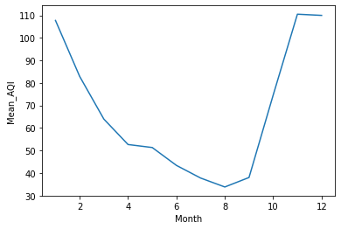

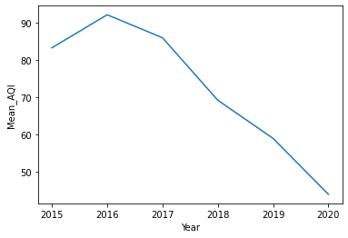

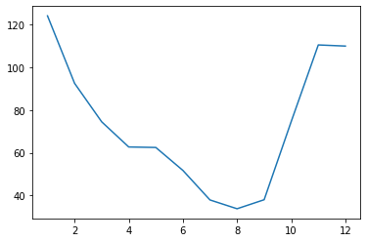

As we can see all over the india we see the triends of PM2.5 levels going down from June to September which is generally the months of monsson.

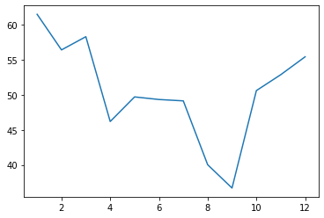Chennai

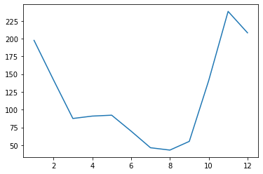delhi

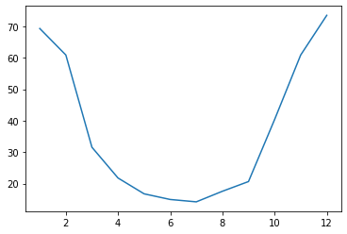Mumbai

The Mansoon,clearly it has effect on PM2.5 as in Delhi and Mumbai in Monsoon years,June,July,August and September (6,7,8,9) PM 2.5 goes way down.Where as in Chennai where monsson reaches far after than these cities,has relatively high PM2.5 in June,July and starts dropping after that.

We can also whow the effect of Humidity in air on PM 2.5 as Mumbai and chennai are costal cities,having higher humidity than Delhi,their graph of PM2.5 goes down where as delhi's graph makes a small platue in around April and May.

**CO- Carbon monoxide**

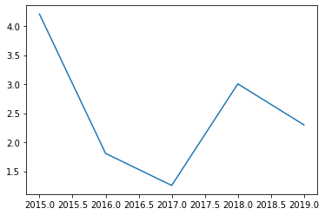

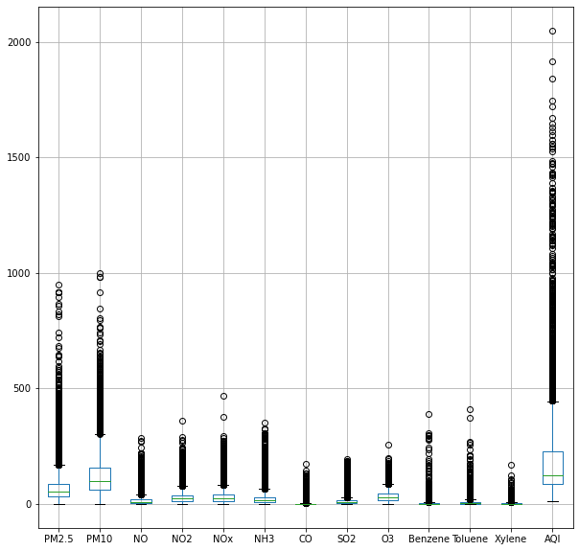

# Difference in three months February,March and April 2020.From Three cities.

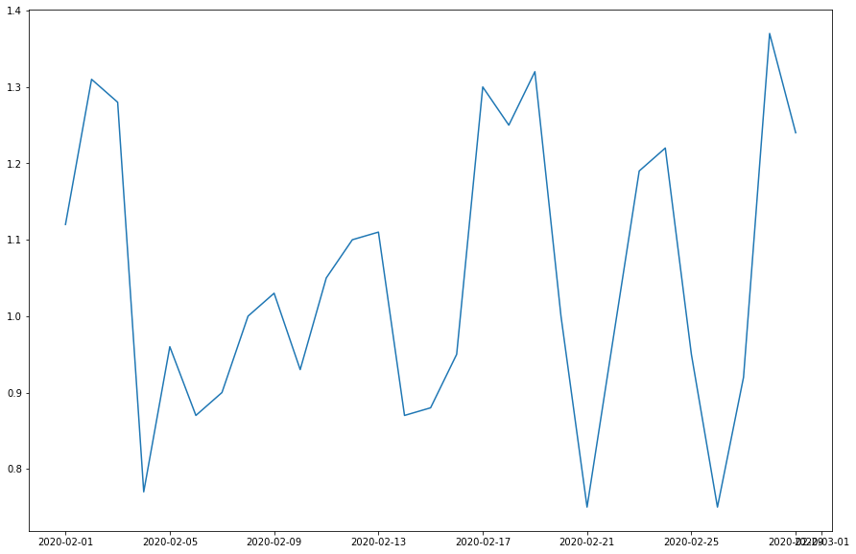feb2020 mumbai

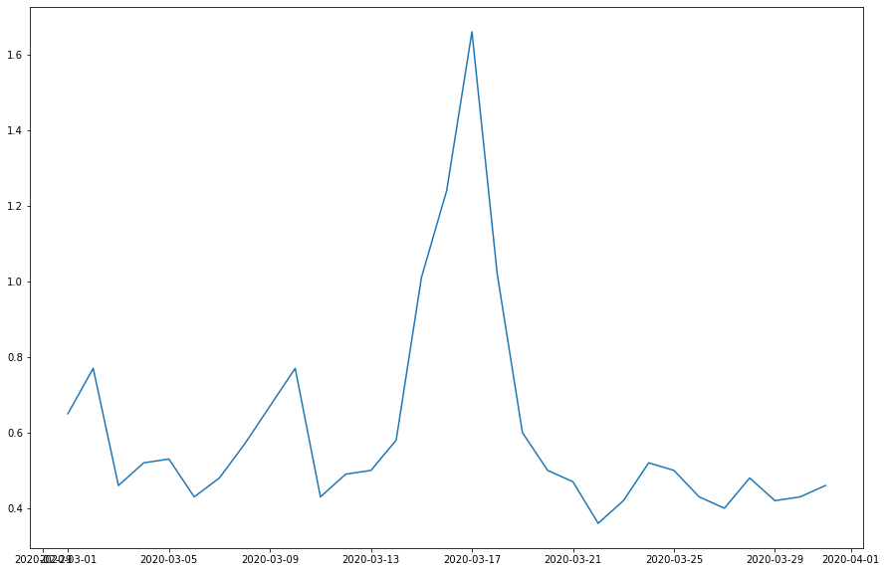march2020, Mumbai

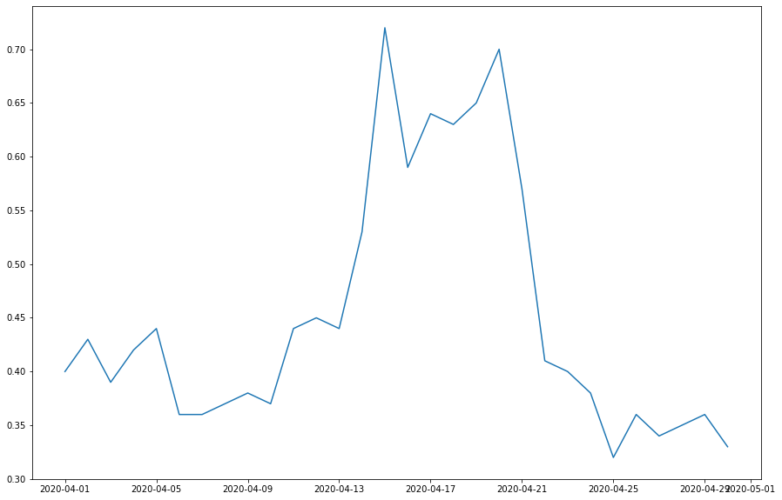april2020, Mumbai

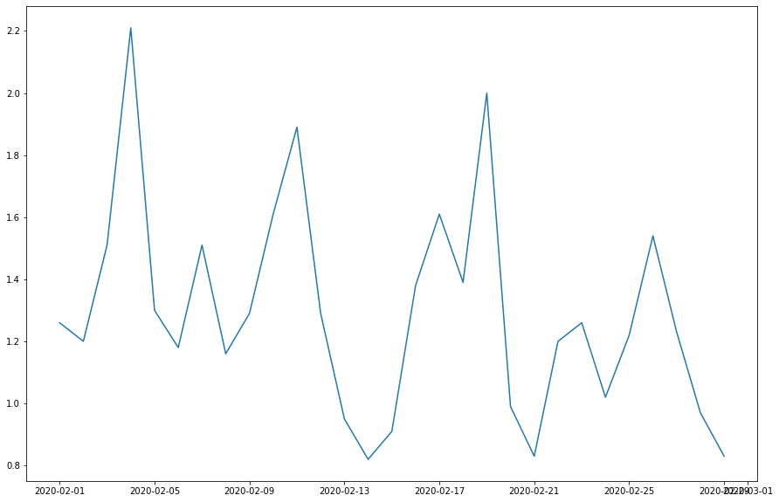feb2020, delhi

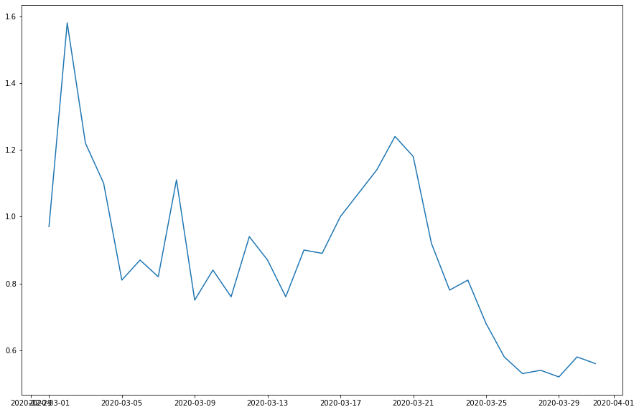march2020, delhi

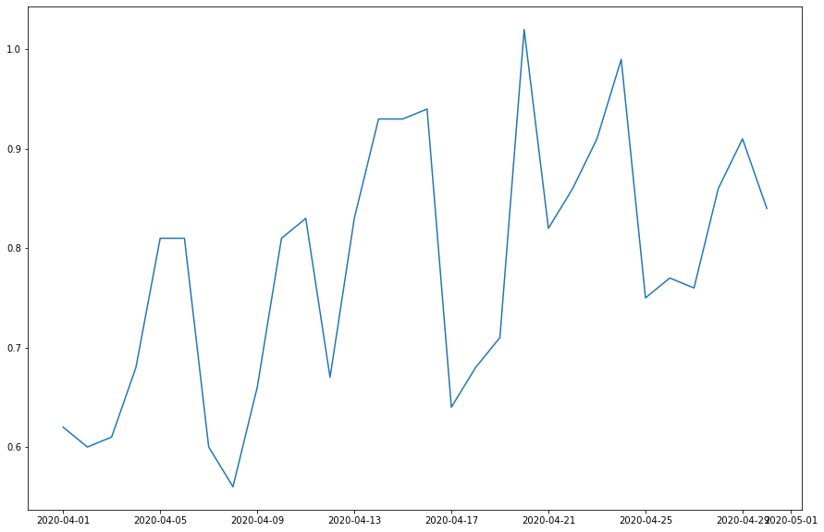april2020, delhi

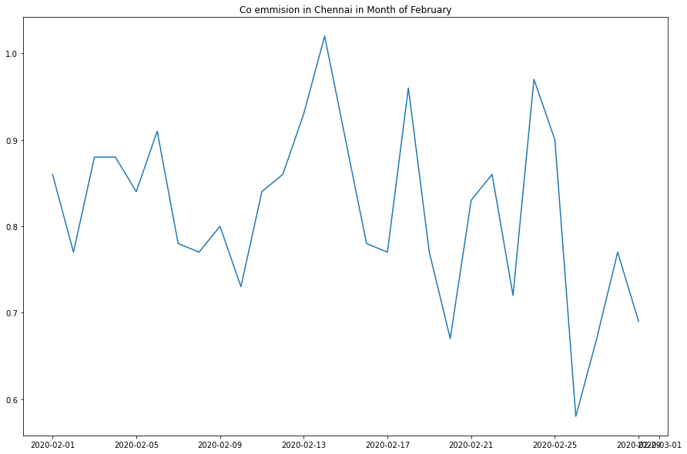feb2020, Chennai

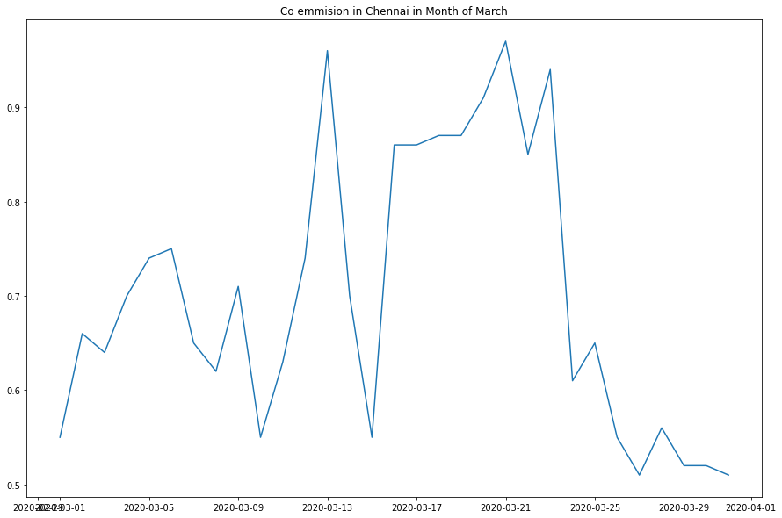march2020, Chennai

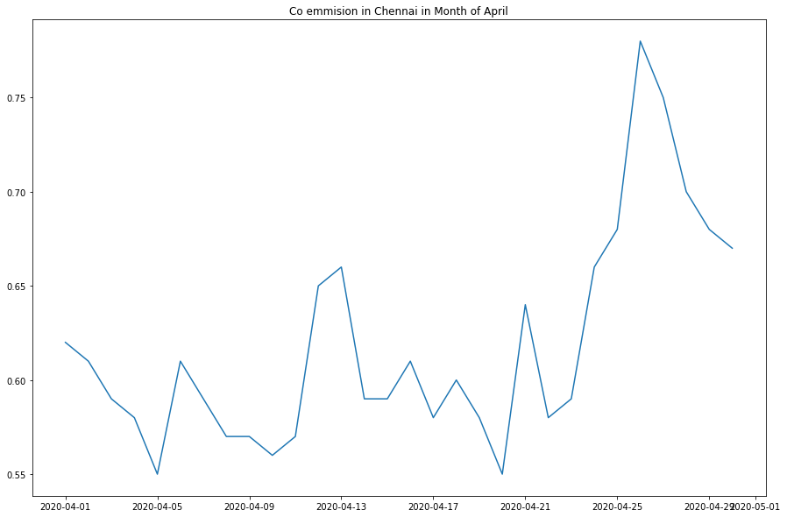april2020, chennai

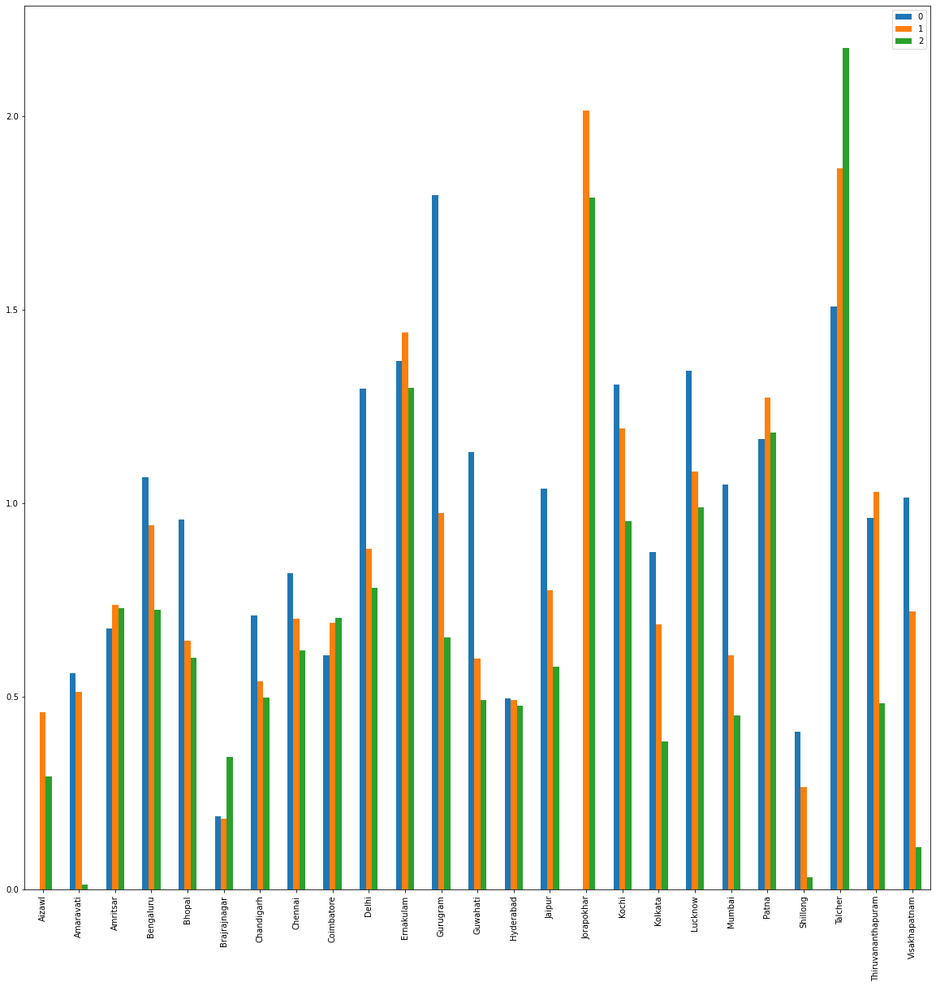

We can see the trend of mean of carbon monoxide emission for 3 months feb,march and april of 2020,which is going down.This trend we can mostly see by large margins in the dense populated cities and famous tourist destinations.One city is different about it and that is Talcher it is shoing eactly opposite trend that of populated cities.lets see more if we can find more about past emissions the city of coal mining,Talcher.

CO does not seem to have effected by monsoon.

Sources of CO:

* Leaving a car in a closed garage with its engine running can produce deadly amounts of CO within 10 minutes.
* Burning charcoal produces CO gas.
* Blocked flues and chimneys can stop CO from escaping.
* Fumes from certain paint removers and cleaning fluids can cause CO poisoning.

**AQI**

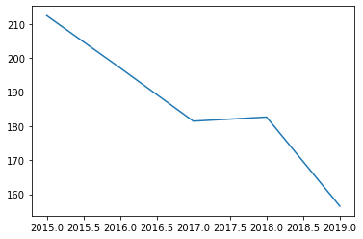

AQI is dropping over the years.This might or might not be because the null values in previous three years.But if we see the 2018 and 2019 around only 11% and 4% data is missing and still we can see the downward flow of AQI.

**NO**

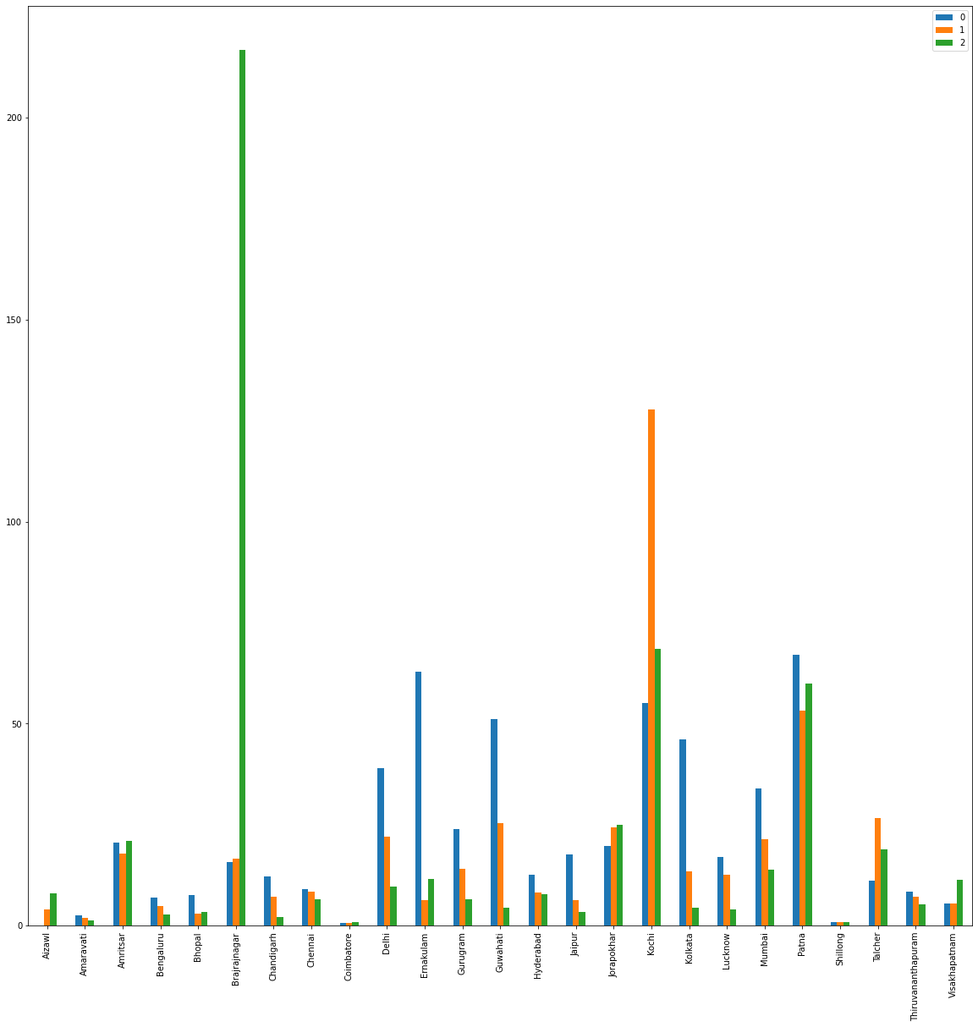

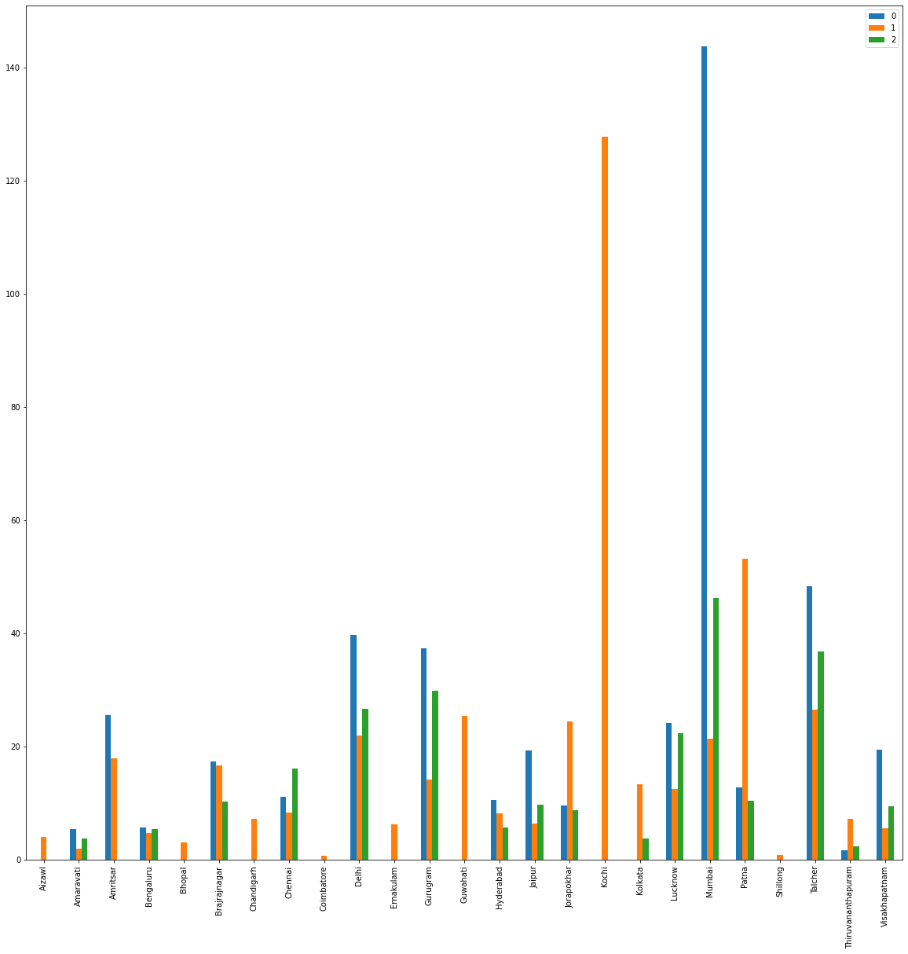

As far as Motropolitan cities like Mumbai,Bengaluru,Delhi,Chandigad,Hydrabad,Chandigad are considered, we can see same trend in nearly all the pollutents in these cities that by february,march and april their levels are dropping and these trends are only in the year 2020.If we see the year 2019 or 2018,we cannot see this dropping trend in especially these cities like we see in 2020.

# Now as the data of May-June is available we can get more insights from the data reagrding effect of lockdown.

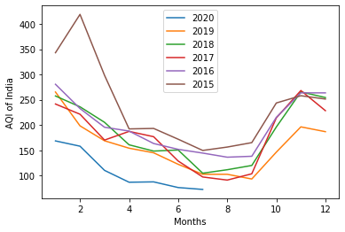

Here you can see the trend of AQI gong down.Through the months in 2020.this data is of Whole india.If you see the every other year has higher AQI = than 2020.But one thing to notice here is staring from January the year is having average less AQI level then others whereas lockdown started in March 25th of the year.So clearly lockdown is not the only one reason behind low AQI levels in the country.

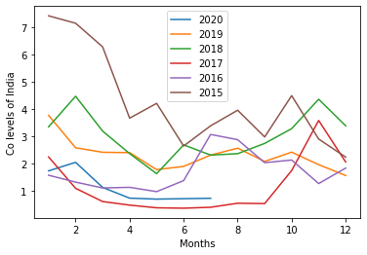

To see real impact of the lockdown we have to see the data at year level i.e 2020 and how AQI levels changed After and before 25th march 2020(Lockown started)

# City wise breakdown of the AQI levels-Mumbai,Delhi and Chennai

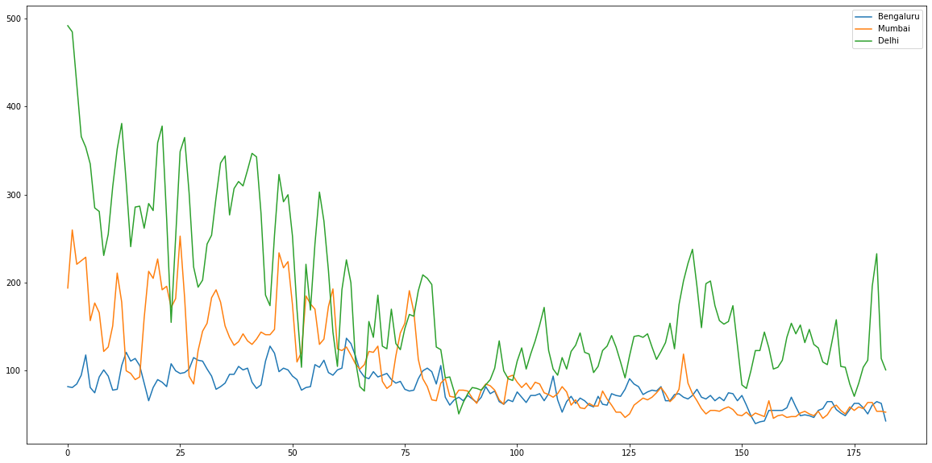

Here relative trend is represented. The number of days from 1st jan to 25th march are :84 and if you see clearly,Every city is showing dropping levels of AQI around that time

CO levels

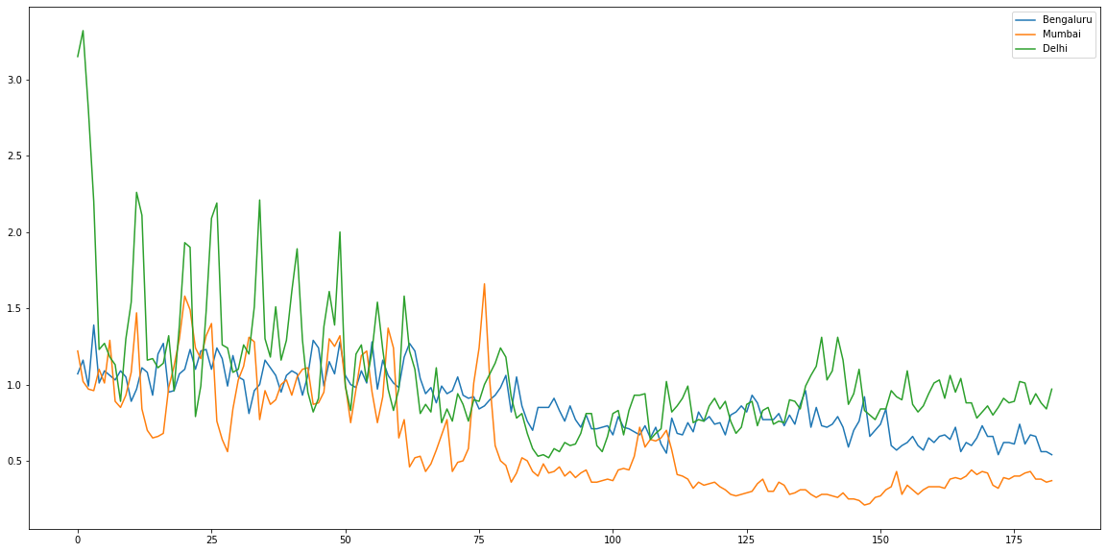

Same trend is showing here,THE DOWNWARDS!



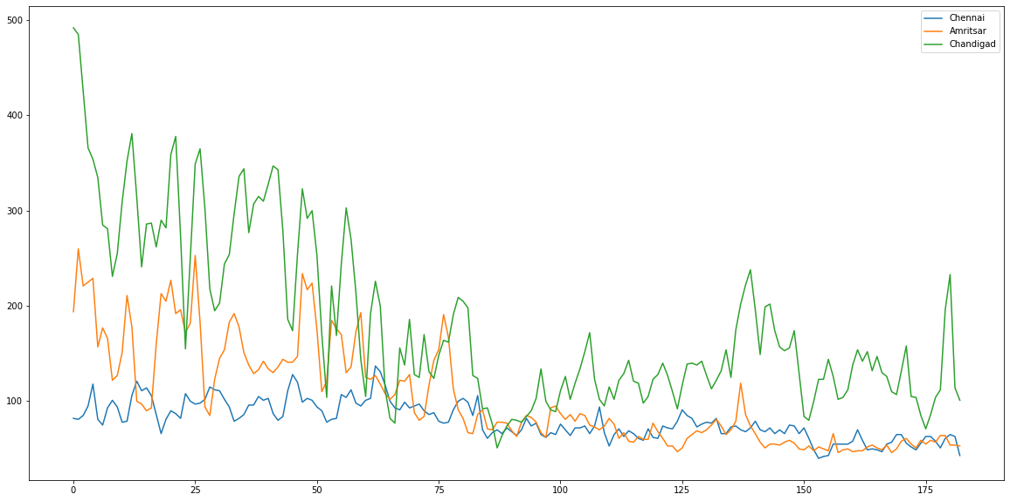

ame trend Again,Proving that Lockdown has lowered the AQI / CO levels in india.

**Result**

Lockdown has lowered the AQI / CO levels in india